**Installing and Configuring Jenkins on CentOS 7 EC2**

• Create CentOS 7 EC2 instance of size t2.micro in the Default VPC ( Allow all traffic in Security Groups) in any region.

• Logon to the EC2 instance using the Public ip and perform the below steps

**Login as:** centos

**Get root privileges -** sudo su -

* Update the packages on the system and install wget

yum update

yum install wget

* Download Jenkins Repository, Import Jenkins key

wget -O /etc/yum.repos.d/jenkins.repo https://pkg.jenkins.io/redhat-stable/jenkins.repo

rpm --import https://pkg.jenkins.io/redhat-stable/jenkins.io.key

* Install Extra Packages for Enterprise Linux & Install jdk 11

yum install epel-release

yum install java-11-openjdk-devel

* Install Jenkins and Start Jenkins Service

yum install jenkins

service jenkins start

• Access the publicip with port and configure Jenkins (<http://publicip:8080>)

* **Get password by running the below command**

cat /var/lib/jenkins/secrets/initialAdminPassword

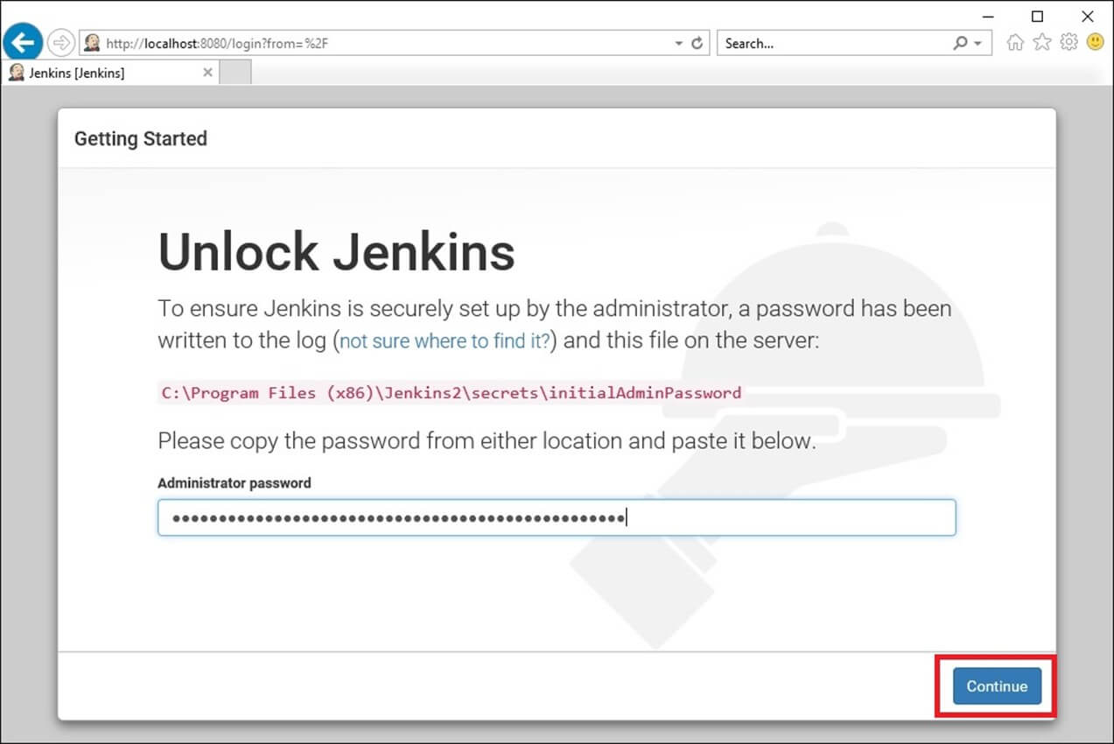

* **Choose Install Recommended Plugins**

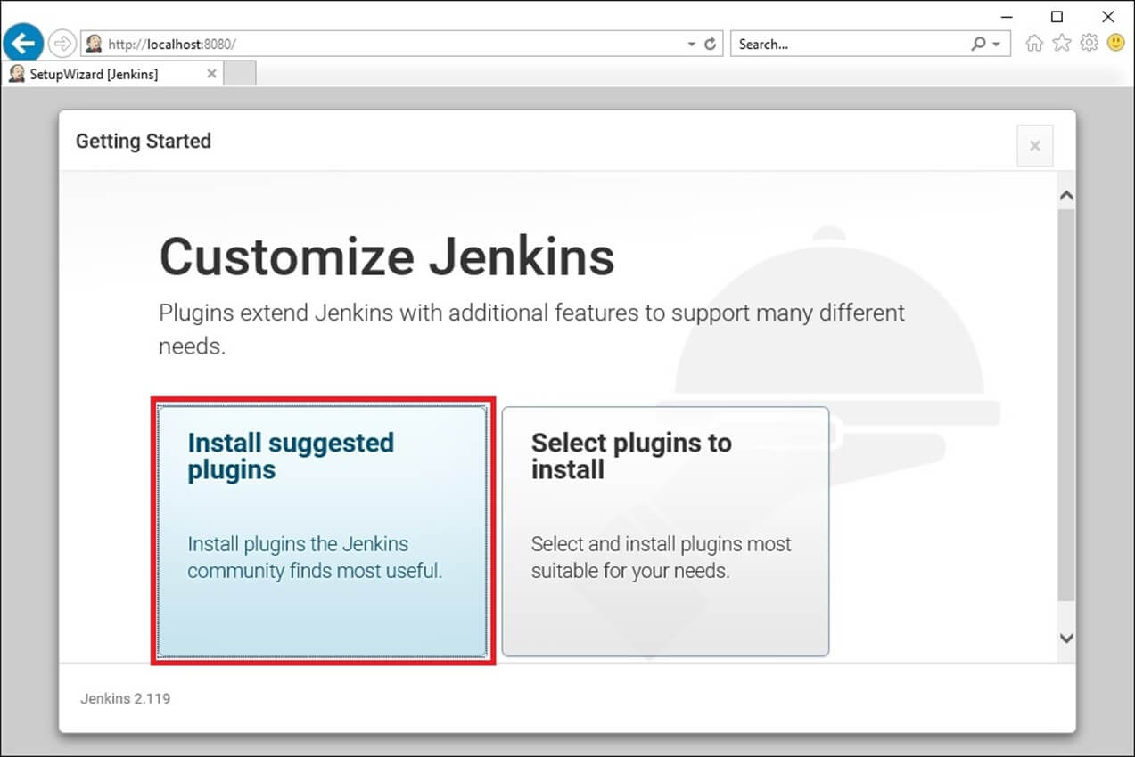

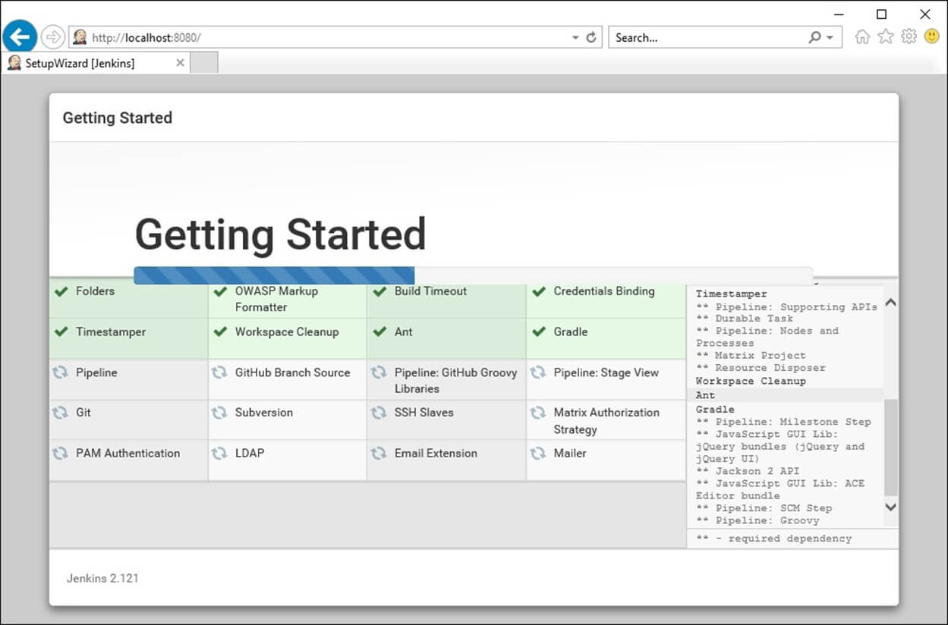

* **Create First username and Password as admin**
* **Enter your name and email id .**
* **Choose default Jenkins URL and finish**

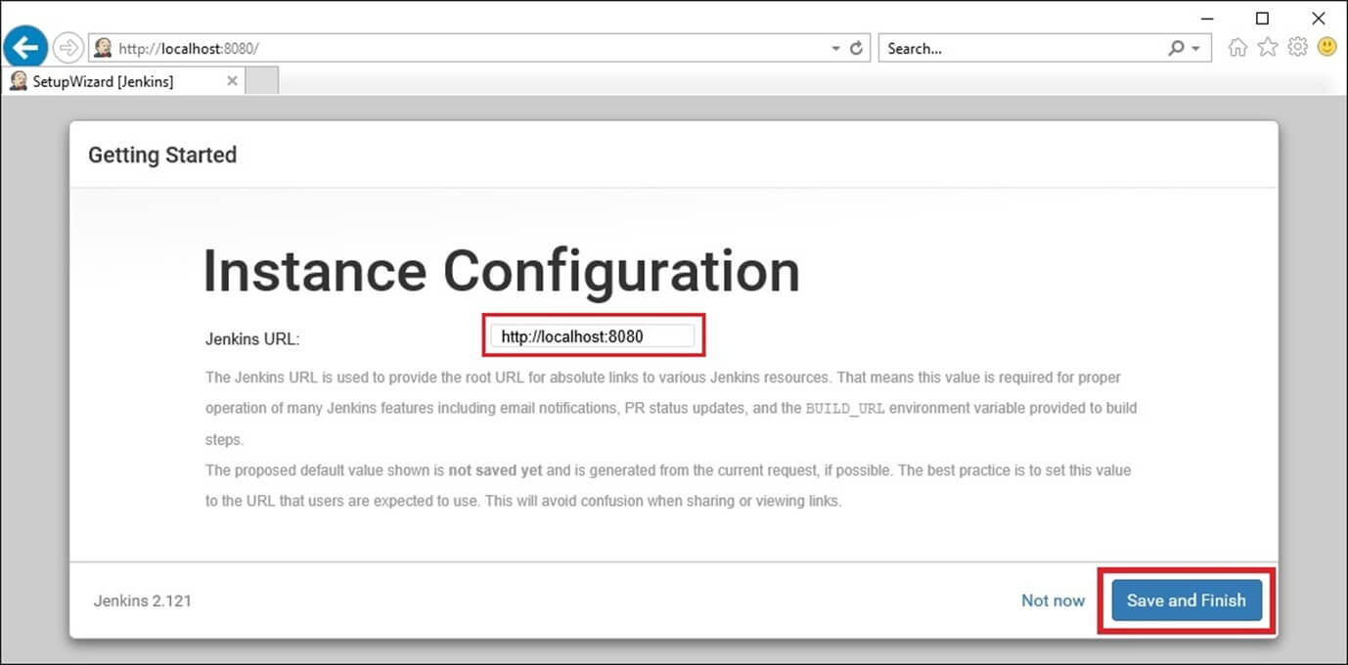

Check the jenkins version:

jenkins --version